Name : alveena naz
Reg # no. : fa25-bse-010
Pf lb activity 6

Activity 1:
import java.util.Scanner;
public class LabJava
{
public static void main(String[] args)
{
Scanner input = new Scanner (System.in);
System.out.println(" enter three points");
double x1= input.nextDouble();
double y1= input.nextDouble();
double x2= input.nextDouble();
double y2= input.nextDouble();
double x3= input.nextDouble();
double y3= input.nextDouble();

double a = Math.sqrt((x2 - x3) * (x2 - x3) + (y2 - y3) * (y2 - y3));
double b = Math.sqrt((x1 - x3) * (x1 - x3) + (y1 - y3) * (y1 - y3));
double c = Math.sqrt((x1-x2) * (x1-x2) + (y1 - y2) * (y1 - y2));

double A = Math.toDegrees(Math.acos((a * a - b * b - c * c )/ (-2 * b * c)));
double B = Math.toDegrees(Math.acos((b * b - a * a - c * c) / (-2 * a * c)));
double C = Math.toDegrees(Math.acos((c * c - b * b - a * a )/ (-2 * a * c)));

System.out.println(" The three angels are " + Math.round( (A * 100)/ 100)+ " " + Math.round((B*100 )/ 100)+ " " + Math.round((C * 100) / 100));

}

}

OUTPUT:

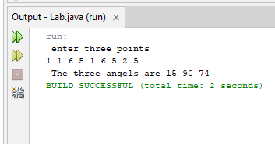

Activity 2:
import java.util.Scanner;
public class LabJava
{
public static void main(String[] args)
{
Scanner input = new Scanner (System.in);
char ch = 'a';
System.out.println(Character.isDigit('a'));
System.out.println(Character.isLetter(ch));
System.out.println(Character.isLowerCase(ch));
System.out.println(Character.isUpperCase(ch));
String ch1 = "T";
System.out.println(ch1.toLowerCase());
String ch2 = "t";
System.out.println(ch1.toUpperCase());
}

}

OUTPUT:
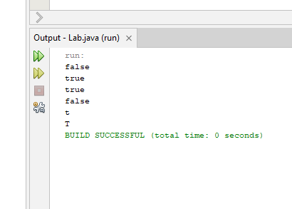

Activity 3:
import java.util.Scanner;
public class LabJava
{
public static void main(String[] args)
{
Scanner input = new Scanner (System.in);
System.out.println(" enter the first city");
String city1 = input.nextLine();
System.out.println(" enter the second city");
String city2 = input.nextLine();
if(city1.compareTo(city2)<0)
System.out.println(" The cities in alphabetical order are " + city1 + " " + city2);
else
System.out.println(" The cities in alphabetical order are " + city2 + " "+ city1);
}

}

OUTPUT:
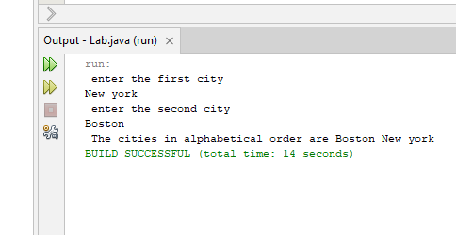

Activity 4:
import java.util.Scanner;
public class LabJava
{
public static void main(String[] args)
{
Scanner input = new Scanner (System.in);
String sent = "Now is the time for the birthday party";
System.out.println(" Sentence = " + sent);
System.out.println(" The length of sentence is " + sent.length());
System.out.println(" The character at index 16 is " + sent.charAt(16));
System.out.println(" The index of the first t is " + sent.indexOf('t'));
System.out.println(" The index of for in sentence is " + sent.indexOf("for"));
System.out.println(" sentence.substring " + sent.substring(0,6));
System.out.println(" sentence.substring = " + sent.substring(7,12));
System.out.println(" sentence.substring = " + sent.substring(7,22));
System.out.println(" sentence.substring = " + sent.substring(4,10));
String str1 = sent.substring(0,8);
System.out.println(" str1 = " + str1);
String str2 = sent.substring(2,12);
System.out.println(" str1 = " + str2);
System.out.println(" Sentence in upper case = " + sent.toUpperCase());
int index = sent.indexOf("birthday");
str1 = sent.substring( index, index + 14);
System.out.println("str1 = " + str1);
System.out.println(" sentence.replace = " + sent.replace('t', 'T'));

}

}

OUTPUT:
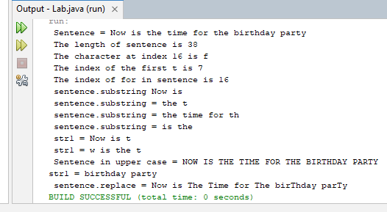

Graded lab task 1:

import java.util.Scanner;
public class FirstJava
{
public static void main(String[] args)
{
Scanner input = new Scanner(System.in);
System.out.println("Enter point 1 (latitude and longitude) in degrees: ");
double latt1= input.nextDouble();
double long1= input.nextDouble();
System.out.println("Enter point 2 (latitude and longitude) in degrees: ");
double latt2= input.nextDouble();
double long2= input.nextDouble();
double radius = 6371.01;
double x1 = Math.toRadians(latt1);
double y1 = Math.toRadians(long1);
double x2 = Math.toRadians(latt2);
double y2 = Math.toRadians(long2);

double d = radius * Math.acos(Math.sin(x1) * Math.sin(x2) + Math.cos(x1) * Math.cos(x2) * Math.cos(y1-y2));
System.out.println(" The distance between the two points " + d);

}
}

OUTPUT:

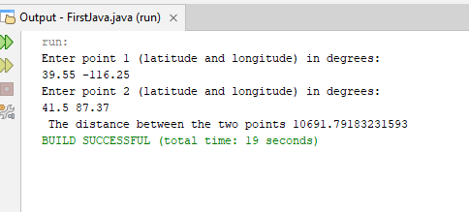

Graded task 2: part (a)
import java.util.Scanner;
public class FirstJava
{
public static void main(String[] args)
{
Scanner input = new Scanner(System.in);
System.out.println("enter a number between 0 and 127");
int num = input.nextInt();

char ch = (char)num;
System.out.println(ch);
}
}

OUTPUT:

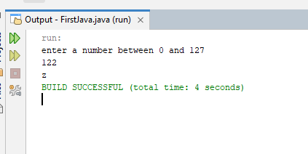

Part(b)

import java.util.Scanner;
public class FirstJava
{
public static void main(String[] args)
{
Scanner input = new Scanner(System.in);
System.out.println("enter a character ");
char ch = input.next().charAt(0);

int num = (int)ch;
System.out.println(num);
}
}

OUTPUT:

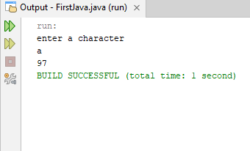

Graded task 3: Part (a)

import java.util.Scanner;
public class LabJava
{
public static void main(String[] args)
{
Scanner input = new Scanner (System.in);
System.out.println(" Enter an integer between 0 and 15");
int decNum = input.nextInt();
if(decNum>=0 && decNum <=15)
{
String hexNum = Integer.toHexString(decNum);
String hexNum1 = hexNum.toUpperCase();
System.out.println(" The hex value is " + hexNum1);
}
else
System.out.println(decNum + " is invalid input");
}

}

OUTPUT:
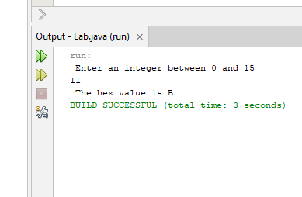

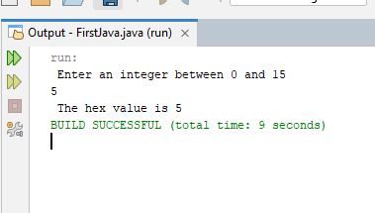

Part(b)

import java.util.Scanner;
public class FirstJava
{
public static void main(String[] args)
{
Scanner input = new Scanner(System.in);
System.out.println("Enter a hex decimal number ");
String hex = input.nextLine();
char ch = hex.charAt(0);
if (ch >= '0' && ch <= '9') {
int value = ch - '0';
System.out.println("The binary value is " + Integer.toBinaryString(value));
} else if (ch >= 'A' && ch <= 'F') {
int value = 10 + (ch - 'A');
System.out.println("The binary value is " + Integer.toBinaryString(value));
} else {
System.out.println(ch + " is an invalid input");
}

}
}

OUTUT:

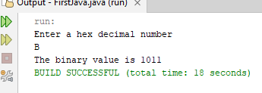

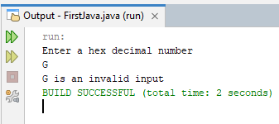

Graded Task 4:

import java.util.Scanner;
public class FirstJava
{
public static void main(String[] args)
{
Scanner input = new Scanner(System.in);
char ch = (char)('A' + (int)(Math.random() * 26));
System.out.println(ch);
}
}

OUTPUT:

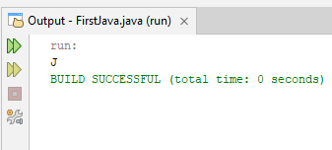

Graded task 5:
import java.util.Scanner;
public class FirstJava
{
public static void main(String[] args)
{
Scanner input = new Scanner(System.in);
System.out.println(" enter a string");
String str = input.next();
char first = str.charAt(0);
char last = str.charAt(str.length() -1);

if(first == last)
{
System.out.println(str + " is a palindrome ");
}
else
System.out.println(str + " is not a palindrome ");
}
}

OUTPUT:

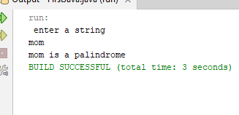

Graded task 6:

import java.util.Scanner;
public class FirstJava
{
public static void main(String[] args)
{
Scanner input = new Scanner(System.in);
System.out.println(" enter a string");
String str = input.nextLine();
int space = str.indexOf(" ");
String str1 = str.substring(0 ,(space+1));
String str2 = str.substring(space);

System.out.println(str2+ " " +str1);

}
}

OUTPUT:

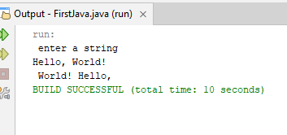

Graded task 7:
import java.util.Scanner;
public class FirstJava
{
public static void main(String[] args)
{
Scanner input = new Scanner(System.in);
System.out.println("enter a string");
String str = input.nextLine();
int first = str.indexOf('f');
int last = str.lastIndexOf('f');
if(first == last)
System.out.println(first);
else
System.out.println(first + " " + last);

}
}

OUTPUT:

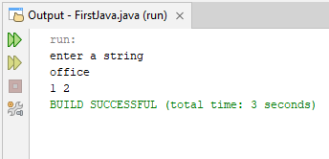

Graded task 8:

import java.util.Scanner;
public class FirstJava
{
public static void main(String[] args)
{
Scanner input = new Scanner(System.in);
System.out.println("enter a string");
String str = input.nextLine();
int first = str.indexOf('h');
int last = str.lastIndexOf('h');

String part1 = str.substring(0,first);
String part2 = str.substring(last+1);
System.out.println(part1 + part2);

}
}

OUTPUT:

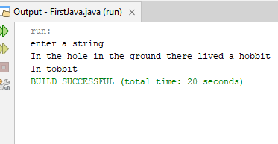

Graded task 9:

import java.util.Scanner;
public class FirstJava
{
public static void main(String[] args)
{
Scanner input = new Scanner(System.in);
System.out.println(" Enter a string ");
String word = input.nextLine();

int first = word.indexOf('h');
int last = word.lastIndexOf('h');
String result = "";
for(int i = 0; i < word.length(); i++)
{
char ch = word.charAt(i);

if(ch == 'h' && (i != first) && (i !=last))
result+='H';
else
result+=ch;
}
System.out.println(" The correct answer is " + result);
}
}

OUTPUT:

Graded task 10:

import java.util.Scanner;
public class FirstJava
{
public static void main(String[] args)
{
Scanner input = new Scanner(System.in);
System.out.println(" Enter a String");
String word = input.next();

System.out.println(word.charAt(2));

System.out.println(word.substring(1));

System.out.println(word.substring(0,5));
System.out.println(word.substring(0,3));

for(int i = 0; i < word.length(); i+=2)
{

System.out.print(word.charAt(i));
}
System.out.println();
for(int i = 1; i < word.length(); i+=2)
{

System.out.print(word.charAt(i));
}
System.out.println();
for(int i = 4; i >=0; i--)
{
System.out.print(word.charAt(i));
}
System.out.println();

for(int i = 4; i >=0; i-=2)
{
System.out.print(word.charAt(i));
}
System.out.println();

System.out.println(word.length());
}

}

OUTPUT:

